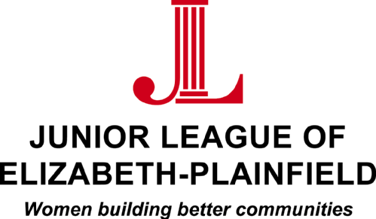

January 2024

RE: JLEP Community Service Scholarships

Dear Scholarship Applicant:

The Junior League of Elizabeth-Plainfield (JLEP) was founded in 1923 and is an organization of women committed to promoting volunteerism, developing the potential of women, and improving the community through the effective action and leadership of trained volunteers. The JLEP has implemented our mission through our projects, fundraisers and advocacy efforts.

Our organization believes that volunteerism is a vital force in our community, and we support young women who share our passion. This year, we will be awarding three $4,000 scholarships to college-bound high school seniors who have demonstrated a commitment to volunteer activities. The scholarships will be awarded in May 2024.

To be considered for a scholarship please complete the enclosed application, write a 300-to-400-word essay about your volunteer experiences, and provide two letters of recommendation. If available, also include the mailing address and contact information for the college you plan to attend, which will be used should you be chosen as a scholarship recipient.

The deadline for submitting applications is April 5, 2024. There will be a formal presentation of the scholarships to the recipients at our JLEP Annual Dinner on May 22, 2024.

Sincerely,

Ginger Clarke-Walden and Christine Lagatta
Scholarship Committee Chairs

