- FOR IMMEDIATE RELEASE
Press Contact:
Junior League of Elizabeth-Plainfield, Suzanne Gallagher
T: (908) 709-1177 / E: information@jlepnj.org

Junior League of Elizabeth-Plainfield To Hold Second Annual Little Black Dress Fundraiser
CRANFORD, NEW JERSEY {October 20th, 2018} – The Junior League of Elizabeth-Plainfield (JLEP) is organizing its second annual Little Black Dress Initiative, a weeklong fundraising campaign that uses the iconic little black dress to raise awareness about poverty and its effects on women in society.
Participants are challenged to wear the same little black dress for five consecutive days along with a pin that reads “Ask Me about my Dress” to spark conversation about the initiative and its objectives. The campaign will both shine a spotlight on the issues surrounding poverty, and raise funds to support the JLEP’s signature projects, Career Closet, which provides professional clothing to low-income women, and Teen Closet, a girls’ empowerment initiative that works with at-risk female high school students in Union County.
“Poverty awareness and working towards remediating the effects of poverty on families is an important focus of the JLEP's work.” said JLEP President Suzanne Gallagher. “According to DataUSA, 10.6% of Union County live in poverty with the largest demographic being females ages 35-44, followed by females 55-64 and females 25-34. As an organization, we strive to develop the potential of women and improve the community in which we live and work. Poverty is clearly one area where our volunteer efforts are needed and can make a demonstrable impact.”
The Little Black Dress Initiative began in 2014 when members of the Junior League of London chose to wear the same black dress to work, parties, and events during London Fashion week to increase awareness of poverty in the community. Since then, Leagues around the world have adopted the event to increase poverty awareness and raise funds for programs combating poverty their own communities.
The LBDI fundraiser will officially kick off on “Giving Tuesday,” November 27th, and will run through Saturday, December 1st. For more information on how to participate or donate, visit blackdressdonate.org. Every dollar donated benefits women and female teens in the Union County Area.
About the Junior League of Elizabeth-Plainfield
The Junior League of Elizabeth-Plainfield is a chapter of the Association of Junior Leagues International, Inc. and is an organization of women committed to promoting voluntarism, developing the potential of women, and improving communities through the effective action and leadership of trained volunteers. Its purpose is exclusively educational and charitable.
For more information about the Junior League of Elizabeth-Plainfield, please contact:
Suzanne Gallagher, President 2018-2019, Junior League of Elizabeth-Plainfield
Tel. (908)709-1177 / E: information@jlepnj.org / W: http://www.jlepnj.org/little-black-dress-2018.html or to donate W: blackdressdonate.org

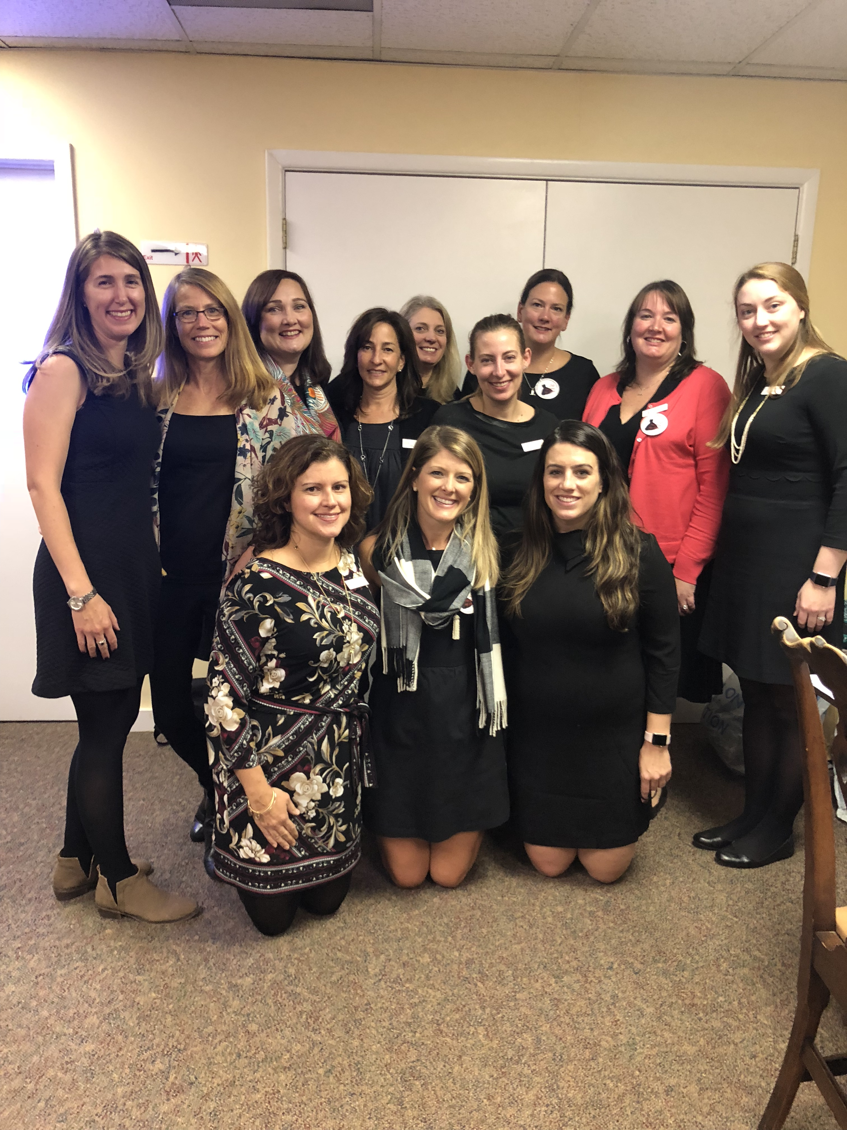
Bottom row (L-R) Laura Lanigan, Ashleigh Nudo, Jackie Neeley
Back Row (L-R) Lindsay Borden, Jeni DiVirgilio, Anne Westpheling, Paula Why, Tara Tepp, Colleen Cusick Endick, Naomi Benson, Suzanne Gallagher, Marie Weitzman

